An Open Letter to the world from Nasreen Sheikh, a survivor of modern day slavery delivered to the International Conference "Eradicating Child Labor, building a better future" held on 19th November 2021. Dicastery for Promoting Integral Human Development.

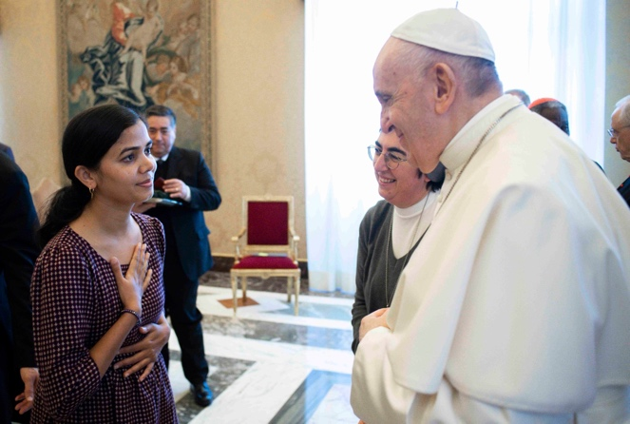
Dear Leaders, CEOs and Board members:
I’m going to tell you something you already know.

You hold the power to initiate global change.

It is my wish that the words I am sharing with you in this letter become more than just words on paper. I am asking you to take action.

Just ONE action taken by you will ripple out into the world with an exponential effect. This effect can challenge many aspects of the existing global trade system.

And what if I promised you that the rewards of your actions will bring more value to the world than profit?

I was born in a remote village where neither birth nor death records are kept. We had no education and lived in poverty. In the absence of enough food we sometimes ate handfuls of clay from the ground to fill our stomachs.

As an undocumented girl born in a conservative, male dominated society, I was not allowed to know the world around me.
If you ask me how old I am, I honestly cannot not tell you! I can guess that I first became a child laborer around the age of 9 or 10.
I was forced to work for a well-known clothing corporation that used loosely regulated factories - sweatshops.

In order to keep up with their demands for low cost and fast production, these illegal sweatshops use and abuse undocumented child workers just like me. Six of us lived, worked and slept in a 10 by 10 room without a bathroom or clean water.

We were forced to work 7 days a week for 10 to 12 hours a day, getting paid less than $2 a day.

My only bed was the large pile of clothes that I’d sewn that day. I hated those clothes, woven with the energy of my suffering. At night I would collapse on to the bundles of clothes and day dream enviously about where they would end up and who would wear them. If you are reading this and do not know who made them, you might be wearing those clothes right now.
In the sweatshops, I saw how chemicals and dyes are illegally discarded into the waterways and drains. I tasted the chemicals in my food and felt them stinging on my skin. I saw the beautiful rivers running throughout Kathmandu poisoned with industrial pollutants, all life extinguished.
I cried for Nature that has never before suffered so much at the hands of irresponsible and unaccountable corporate manufacturers.

And there I was, in the vicious cycle of modern slavery. Along with 40.3 million men, women and children from around the world I was being exploited at the hands of global consumerism.
But these global crimes are hidden in many layers of the supply chain and later once I had escaped the sweatshops, I was shocked to learn that only 4% of businesses are committed to transparency.
It is unacceptable that 136 countries still fail to legislate against forced marriage, child labor and extreme poverty. That shocks me to my core.
Are you committed to people like us or do you put profit first? If you met me, would I matter? Do you see me as a person who is impacted by your decisions?
Here’s the important message:
I do not want to shame you. I do not blame you for stealing my childhood or polluting this planet. But it happened.
You did not do this alone. We did this collectively and we must all be accountable. So I forgive you, and I forgive myself and all of the people who caused harm in my childhood

If we keep blaming each other we will remain distanced and no good will come of this conversation.
So, I am asking you to consider the following:

Will you pledge to investigate every part of the supply chain of everything you produce, everything you sell and everything you buy. And if one person in one part of that chain does not have access to a Protected Environment, Clean Water, Nutritious Food, Safe Shelter, Quality Education, Health Care and Access to Technology then will you pledge to change it using your power and your leadership?

This starts with your belief that you CAN generate Profit by putting People & Planet first. There is enough for everyone.

Will you trade your focus on benefits to your shareholders with creating value for each and every stakeholder?

Will you trade pollution for agreements to protect the earth?

Will you trade working with loosely regulated foreign manufacturers and create shared value with disadvantaged but capable producers.

Will you stop forced and child labor and provide equal workers’ rights for all men and women and trade slave labor wages for living wages?

The little girl that survived all this and more is a woman now.

I am Nasreen Sheikh. I am approximately 28, 29 years old and the founder of Local Women’s Handicrafts and Empowerment Collective in Nepal & USA on a mission to end modern day slavery. It has taken years of healing and sacrifice to bring this message to you.

I invite inspired people, businesses, governments, and media, to address these injustices. I invite you to do the same. Please join our 7 Keys for Global Human Rights Campaign that holds the power to unlock unlimited resources. https://empowermentcollective.org/

May peace be with you.
Yours faithfully
Nasreen Sheikh

