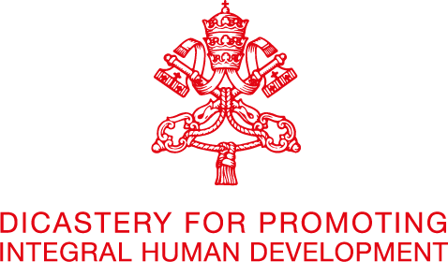
VIDEO CONFERENCES ON:
“Accompanying Health Care Workers in the Context of the Covid-19 Pandemic”
8, 9 and 10 June 2021

1. Concept Note
The health emergency caused by the Covid-19 pandemic has been very demanding on health workers, sometimes to the point of exhaustion. It has enormously increased the workload entrusted to them, their physical fatigue and affected their psychological well-being, seriously increasing the risk of repercussions on mental health - in the short and long term - due to the highly stressful conditions.
Working on the frontline of the response to the emergency, health workers and other health actors were exposed to maximum stress due to, inter alia, heavy work shifts, lack of personal protective equipment and therefore exposed to the risk of infection, physical fatigue, reduction of human resources and breakdown of normal family relationships, which often led to their physical and mental exhaustion. Health professions, per se, involve interpersonal involvement and constant contact with human suffering. The pandemic has increased this reality exponentially. Every day the various health actors are confronted with critical situations that not only require technical competence but also empathy and emotional participation in a prolonged context of strong psychological as well as physical stress.
In the face of the alarming threat to the health of medical personnel, we are all called, just like the Good Samaritan, to act as neighbors; to become a community of “men and women who identify with the vulnerability of others, who reject the creation of a society of exclusion, and act instead as neighbours, lifting up and rehabilitating the fallen for the sake of the common good.” (Fratelli tutti, n.67). The awareness of the impact that the pandemic has had on health professionals and on all those involved in the care and assistance network in various capacities, invites us to pay attention to an important question: how do we take care of those who cared for us and continue to care for others? Or other similar questions: What support can we offer? How should health and pastoral workers at the front line of the pandemic, who now run the risk of burnout be accompanied? How can we protect the integral health of professionals that offer care and assistance? What have we learned from the pandemic about the relationship between people who offer care and those cared for? What role did doctors play in the decision-making process?
In order to be able to respond to these questions and possibly propose lines of action or recommendations, it is first, necessary to listen to those who are involved in care and assistance, so as understand better their experience and recognize their needs. In this regard, at least five videoconferences will be organized, at which some representatives of the various health professions will be given a voice, in order to propose guidelines for the "care for care professionals".

